**附件**

**始兴县乡镇级饮用水水源地保护区划分方案（征求意见稿）**

| **序号** | **服务**  **乡镇** | **水源地名称** | **水源地类型** | **保护区**  **类型** | **水质保护目标** | **水域保护范围** | **陆域保护范围** | **保护区面积(km2)** |
| --- | --- | --- | --- | --- | --- | --- | --- | --- |
| 1 | 澄江镇 | 澄江镇澄江村及墟镇饮用水水源地 | 河流型 | 一级保护区 | Ⅱ类 | 取水口下游100米以上全部水域范围 | 相应一级保护区水域的两岸正常岸线向陆纵深至第一重山山脊线内的陆域集雨范围 | 0.733 |
| 2 | 罗坝镇 | 罗坝镇上岗饮用水水源地 | 河流型 | 一级保护区 | Ⅱ类 | 取水口下游以路为界以上全部水域范围 | 相应一级保护区水域的两岸正常岸线向陆纵深至第一重山山脊线的陆域集雨范围 | 1.135 |
| 3 | 司前镇 | 司前镇李屋饮用水水源地 | 河流型 | 一级保护区 | Ⅱ类 | 取水口下游100米至上游1500米水域范围 | 相应一级保护区水域的两岸正常岸线向陆纵深至第一重山山脊线的陆域集雨范围 | 1.250 |
| 二级保护区 | Ⅱ类 | 一级保护区水域上游边界至上游2500米水域范围 | 相应二级保护区水域的两岸正常岸线向陆纵深至第一重山山脊线的陆域集雨范围 | 3.381 |
| 4 | 隘子镇 | 隘子镇石井饮用水水源地 | 河流型 | 一级保护区 | Ⅱ类 | 取水口下游100米至上游1500米水域范围 | 相应一级保护区水域的两岸正常岸线向陆纵深至第一重山山脊线的陆域集雨范围 | 1.689 |
| 二级保护区 | Ⅱ类 | 一级保护区水域上游边界至上游2500米水域范围 | 相应二级保护区水域的两岸正常岸线向陆纵深至第一重山山脊线的陆域集雨范围 | 5.777 |
| 5 | 深渡水瑶族乡 | 深渡水瑶族乡太阳窝饮用水水源地 | 河流型 | 一级保护区 | Ⅱ类 | 取水口下游100米至上游1500米水域范围 | 相应一级保护区水域的两岸正常岸线向陆纵深至第一重山山脊线内的陆域集雨范围 | 1.650 |
| 二级保护区 | Ⅱ类 | 一级保护区水域上游边界至上游2500米水域范围 | 相应二级保护区水域的两岸正常岸线向陆纵深至第一重山山脊线的陆域集雨范围 | 4.968 |

各保护区的拐点坐标详见表 1~5。

**表1 澄江镇澄江村及墟镇饮用水水源地保护区拐点坐标**

|  |  |  |  |  |
| --- | --- | --- | --- | --- |
| 编号 | 经度 | 纬度 | X | Y |
| SC01Y | 114.322601 | 24.939296 | 38532583 | 2759368 |
| SC02Y | 114.322487 | 24.938986 | 38532571 | 2759334 |
| SC03Y | 114.319760 | 24.939002 | 38532296 | 2759335 |
| SC04Y | 114.317063 | 24.938980 | 38532023 | 2759332 |
| SC05Y | 114.315612 | 24.940037 | 38531877 | 2759449 |
| SC06Y | 114.313254 | 24.939608 | 38531639 | 2759401 |
| SC07Y | 114.310320 | 24.940852 | 38531342 | 2759538 |
| SC08Y | 114.312582 | 24.943985 | 38531570 | 2759886 |
| SC09Y | 114.315824 | 24.946436 | 38531896 | 2760158 |
| SC10Y | 114.317052 | 24.947063 | 38532020 | 2760228 |
| SC11Y | 114.319878 | 24.945797 | 38532306 | 2760088 |
| SC12Y | 114.322552 | 24.944331 | 38532576 | 2759926 |
| SC13Y | 114.322405 | 24.942671 | 38532562 | 2759742 |
| SC14Y | 114.322468 | 24.940680 | 38532569 | 2759522 |
| SC15Y | 114.322750 | 24.939626 | 38532598 | 2759405 |
| **国家大地2000坐标系** | | | | |

**表2 罗坝镇上岗饮用水水源地保护区拐点坐标**

|  |  |  |  |  |
| --- | --- | --- | --- | --- |
| 编号 | 经度 | 纬度 | X | Y |
| SL01Y | 114.198224 | 24.836675 | 38520037 | 2747977 |
| SL02Y | 114.196605 | 24.835119 | 38519874 | 2747804 |
| SL03Y | 114.195892 | 24.834415 | 38519802 | 2747726 |
| SL04Y | 114.194472 | 24.835649 | 38519658 | 2747863 |
| SL05Y | 114.192904 | 24.836886 | 38519499 | 2748000 |
| SL06Y | 114.191711 | 24.837752 | 38519379 | 2748095 |
| SL07Y | 114.190714 | 24.837875 | 38519278 | 2748109 |
| SL08Y | 114.188941 | 24.838871 | 38519098 | 2748219 |
| SL09Y | 114.190677 | 24.839837 | 38519274 | 2748326 |
| SL10Y | 114.193127 | 24.839719 | 38519521 | 2748313 |
| SL11Y | 114.196455 | 24.838482 | 38519858 | 2748177 |
| SL12Y | 114.198668 | 24.837248 | 38520082 | 2748040 |
| SL13Y | 114.184732 | 24.827968 | 38518675 | 2747010 |
| SL14Y | 114.185199 | 24.827285 | 38518722 | 2746935 |
| SL15Y | 114.183940 | 24.825500 | 38518595 | 2746737 |
| SL16Y | 114.182868 | 24.824469 | 38518487 | 2746623 |
| SL17Y | 114.178225 | 24.824982 | 38518017 | 2746679 |
| SL18Y | 114.170687 | 24.825005 | 38517255 | 2746680 |
| SL19Y | 114.170643 | 24.827026 | 38517250 | 2746904 |
| SL20Y | 114.172286 | 24.830212 | 38517416 | 2747258 |
| SL21Y | 114.173502 | 24.830937 | 38517539 | 2747338 |
| SL22Y | 114.176530 | 24.832739 | 38517845 | 2747538 |
| SL23Y | 114.179679 | 24.832904 | 38518163 | 2747557 |
| SL24Y | 114.180961 | 24.829984 | 38518293 | 2747233 |
| SL25Y | 114.182405 | 24.829631 | 38518439 | 2747194 |
| SL26Y | 114.183040 | 24.828532 | 38518503 | 2747073 |
| **国家大地2000坐标系** | | | | |

**表3 司前镇李屋饮用水水源地保护区拐点坐标**

|  |  |  |  |  |
| --- | --- | --- | --- | --- |
| 编号 | 经度 | 纬度 | X | Y |
| SQ01Y | 114.113393 | 24.708010 | 38511474 | 2733715 |
| SQ02Y | 114.112984 | 24.709885 | 38511432 | 2733923 |
| SQ03Y | 114.108965 | 24.710634 | 38511026 | 2734005 |
| SQ04Y | 114.108902 | 24.713053 | 38511019 | 2734273 |
| SQ05Y | 114.112368 | 24.715290 | 38511370 | 2734521 |
| SQ06Y | 114.112576 | 24.718021 | 38511390 | 2734824 |
| SQ07Y | 114.120615 | 24.716943 | 38512204 | 2734705 |
| SQ08Y | 114.122118 | 24.713426 | 38512356 | 2734316 |
| SQ09Y | 114.123812 | 24.713501 | 38512528 | 2734324 |
| SQ10Y | 114.124501 | 24.709526 | 38512598 | 2733884 |
| SQ11Y | 114.122739 | 24.707801 | 38512420 | 2733693 |
| SQ12Y | 114.118805 | 24.708342 | 38512021 | 2733752 |
| SQ13Y | 114.113901 | 24.707689 | 38511525 | 2733679 |
| SQ14 | 114.114825 | 24.723637 | 38511617 | 2735446 |
| SQ15 | 114.120856 | 24.726133 | 38512227 | 2735723 |
| SQ16 | 114.122741 | 24.727708 | 38512418 | 2735898 |
| SQ17 | 114.125020 | 24.731958 | 38512648 | 2736369 |
| SQ18 | 114.128656 | 24.732169 | 38513016 | 2736392 |
| SQ19 | 114.132160 | 24.732023 | 38513370 | 2736377 |
| SQ20 | 114.136080 | 24.729153 | 38513767 | 2736059 |
| SQ21 | 114.135109 | 24.726025 | 38513669 | 2735712 |
| SQ22 | 114.132650 | 24.726099 | 38513421 | 2735720 |
| SQ23 | 114.131027 | 24.724060 | 38513257 | 2735494 |
| SQ24 | 114.133224 | 24.724097 | 38513479 | 2735499 |
| SQ25 | 114.131999 | 24.720040 | 38513355 | 2735049 |
| SQ26 | 114.134977 | 24.719949 | 38513657 | 2735039 |
| SQ27 | 114.138239 | 24.718551 | 38513987 | 2734885 |
| SQ28 | 114.136710 | 24.715196 | 38513833 | 2734513 |
| SQ29 | 114.133556 | 24.714382 | 38513513 | 2734423 |
| SQ30 | 114.131391 | 24.714856 | 38513294 | 2734475 |
| SQ31 | 114.129633 | 24.713640 | 38513117 | 2734340 |
| SQ32 | 114.128191 | 24.713311 | 38512971 | 2734304 |
| SQ33 | 114.128156 | 24.710611 | 38512967 | 2734004 |
| SQ34 | 114.126825 | 24.710907 | 38512833 | 2734037 |
| **国家大地2000坐标系** | | | | |

**表4 隘子镇石井饮用水水源地保护区拐点坐标**

|  |  |  |  |  |
| --- | --- | --- | --- | --- |
| 编号 | 经度 | 纬度 | X | Y |
| SA01Y | 113.923708 | 24.584403 | 38492273 | 2720021 |
| SA02Y | 113.925622 | 24.581268 | 38492466 | 2719673 |
| SA03Y | 113.927994 | 24.580428 | 38492707 | 2719580 |
| SA04Y | 113.927930 | 24.577998 | 38492700 | 2719311 |
| SA05Y | 113.928568 | 24.576440 | 38492764 | 2719138 |
| SA06Y | 113.927942 | 24.574978 | 38492701 | 2718977 |
| SA07Y | 113.922336 | 24.575281 | 38492133 | 2719010 |
| SA08Y | 113.917729 | 24.574922 | 38491666 | 2718971 |
| SA09Y | 113.915977 | 24.576228 | 38491489 | 2719116 |
| SA10Y | 113.912698 | 24.576979 | 38491157 | 2719199 |
| SA11Y | 113.912790 | 24.579358 | 38491166 | 2719463 |
| SA12Y | 113.911283 | 24.582877 | 38491014 | 2719852 |
| SA13Y | 113.911099 | 24.585962 | 38490996 | 2720194 |
| SA14Y | 113.913893 | 24.585694 | 38491279 | 2720164 |
| SA15Y | 113.917745 | 24.587279 | 38491669 | 2720340 |
| SA16Y | 113.920564 | 24.586762 | 38491954 | 2720282 |
| SA17Y | 113.923269 | 24.585385 | 38492228 | 2720129 |
| SA18 | 113.915922 | 24.573993 | 38491483 | 2718868 |
| SA19 | 113.914513 | 24.570899 | 38491340 | 2718525 |
| SA20 | 113.918015 | 24.567682 | 38491695 | 2718169 |
| SA21 | 113.918246 | 24.564780 | 38491718 | 2717847 |
| SA22 | 113.917928 | 24.562711 | 38491686 | 2717618 |
| SA23 | 113.916550 | 24.560597 | 38491546 | 2717384 |
| SA24 | 113.911999 | 24.561980 | 38491085 | 2717538 |
| SA25 | 113.907598 | 24.563148 | 38490639 | 2717667 |
| SA26 | 113.902218 | 24.567175 | 38490095 | 2718114 |
| SA27 | 113.897819 | 24.568469 | 38489649 | 2718257 |
| SA28 | 113.894696 | 24.571328 | 38489333 | 2718574 |
| SA29 | 113.892765 | 24.575512 | 38489138 | 2719038 |
| SA30 | 113.893817 | 24.579501 | 38489245 | 2719480 |
| SA31 | 113.896225 | 24.588068 | 38489489 | 2720428 |
| SA32 | 113.896618 | 24.596240 | 38489530 | 2721334 |
| SA33 | 113.900718 | 24.595039 | 38489945 | 2721200 |
| SA34 | 113.903469 | 24.593944 | 38490223 | 2721079 |
| SA35 | 113.905610 | 24.592548 | 38490440 | 2720924 |
| SA36 | 113.905824 | 24.589825 | 38490462 | 2720622 |
| SA37 | 113.909258 | 24.586946 | 38490809 | 2720303 |
| **国家大地2000坐标系** | | | | |

**表5 深渡水瑶族乡太阳窝饮用水水源地保护区拐点坐标**

|  |  |  |  |  |
| --- | --- | --- | --- | --- |
| 编号 | 经度 | 纬度 | X | Y |
| SS01Y | 114.065964 | 24.847764 | 38506667 | 2749192 |
| SS02Y | 114.065319 | 24.846156 | 38506602 | 2749014 |
| SS03Y | 114.062911 | 24.845823 | 38506359 | 2748977 |
| SS04Y | 114.058750 | 24.848978 | 38505938 | 2749326 |
| SS05Y | 114.052544 | 24.850378 | 38505311 | 2749481 |
| SS06Y | 114.053280 | 24.852836 | 38505385 | 2749754 |
| SS07Y | 114.054630 | 24.856478 | 38505521 | 2750157 |
| SS08Y | 114.057876 | 24.855760 | 38505849 | 2750078 |
| SS09Y | 114.061131 | 24.859369 | 38506178 | 2750478 |
| SS10Y | 114.064569 | 24.858953 | 38506526 | 2750432 |
| SS11Y | 114.066681 | 24.859491 | 38506739 | 2750491 |
| SS12Y | 114.070361 | 24.858598 | 38507111 | 2750393 |
| SS13Y | 114.071623 | 24.858181 | 38507239 | 2750346 |
| SS14Y | 114.070115 | 24.855207 | 38507086 | 2750017 |
| SS15Y | 114.068256 | 24.854300 | 38506899 | 2749916 |
| SS16Y | 114.066395 | 24.850981 | 38506711 | 2749549 |
| SS17Y | 114.066630 | 24.849595 | 38506734 | 2749395 |
| SS18 | 114.047138 | 24.852339 | 38504764 | 2749698 |
| SS19 | 114.038870 | 24.855035 | 38503928 | 2749997 |
| SS20 | 114.041678 | 24.859148 | 38504212 | 2750452 |
| SS21 | 114.043564 | 24.862816 | 38504403 | 2750859 |
| SS22 | 114.047734 | 24.868471 | 38504824 | 2751485 |
| SS23 | 114.052712 | 24.869761 | 38505327 | 2751628 |
| SS24 | 114.057635 | 24.870810 | 38505824 | 2751745 |
| SS25 | 114.068710 | 24.871187 | 38506943 | 2751787 |
| SS26 | 114.076851 | 24.867839 | 38507766 | 2751417 |
| SS27 | 114.075828 | 24.864973 | 38507663 | 2751099 |
| SS28 | 114.075013 | 24.861635 | 38507581 | 2750729 |
| SS29 | 114.072420 | 24.858359 | 38507319 | 2750366 |
| **国家大地2000坐标系** | | | | |

图1 澄江镇澄江村及虚镇饮用水源保护区范围图

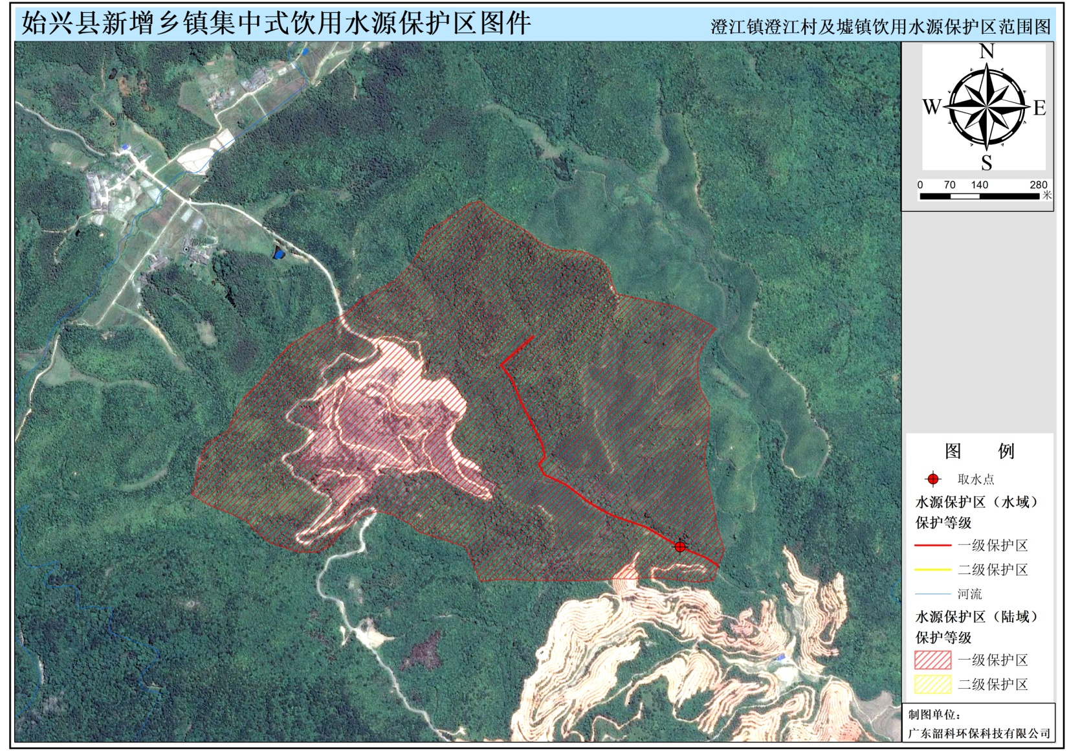

图2 罗坝镇上岗饮用水源保护区范围图

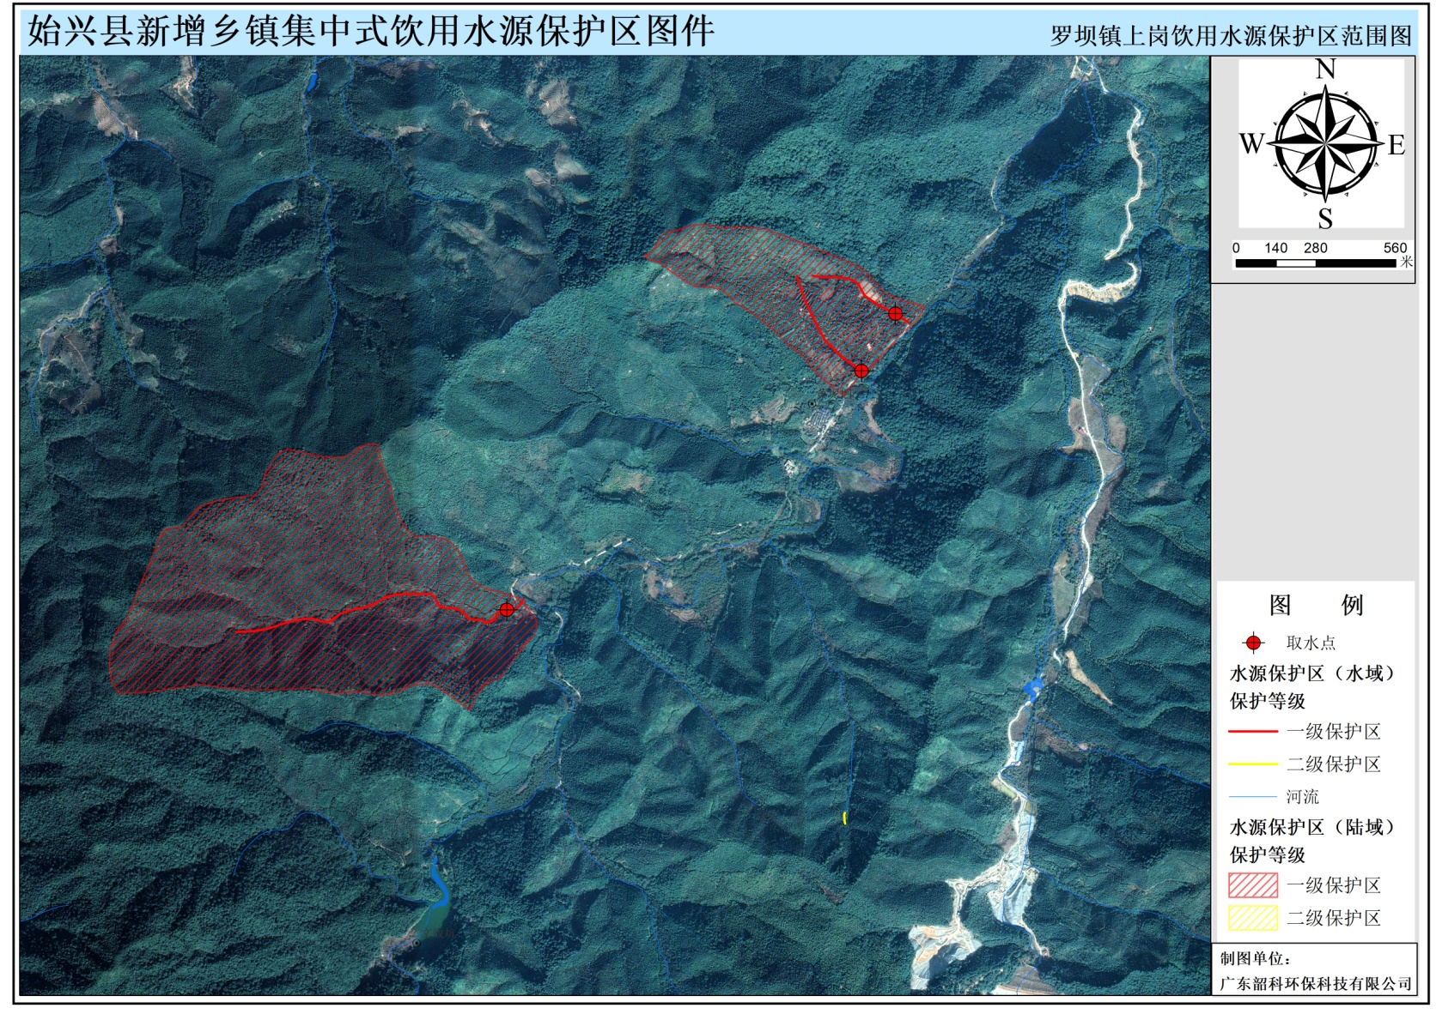

图3 司前镇李屋饮用水源保护区范围图

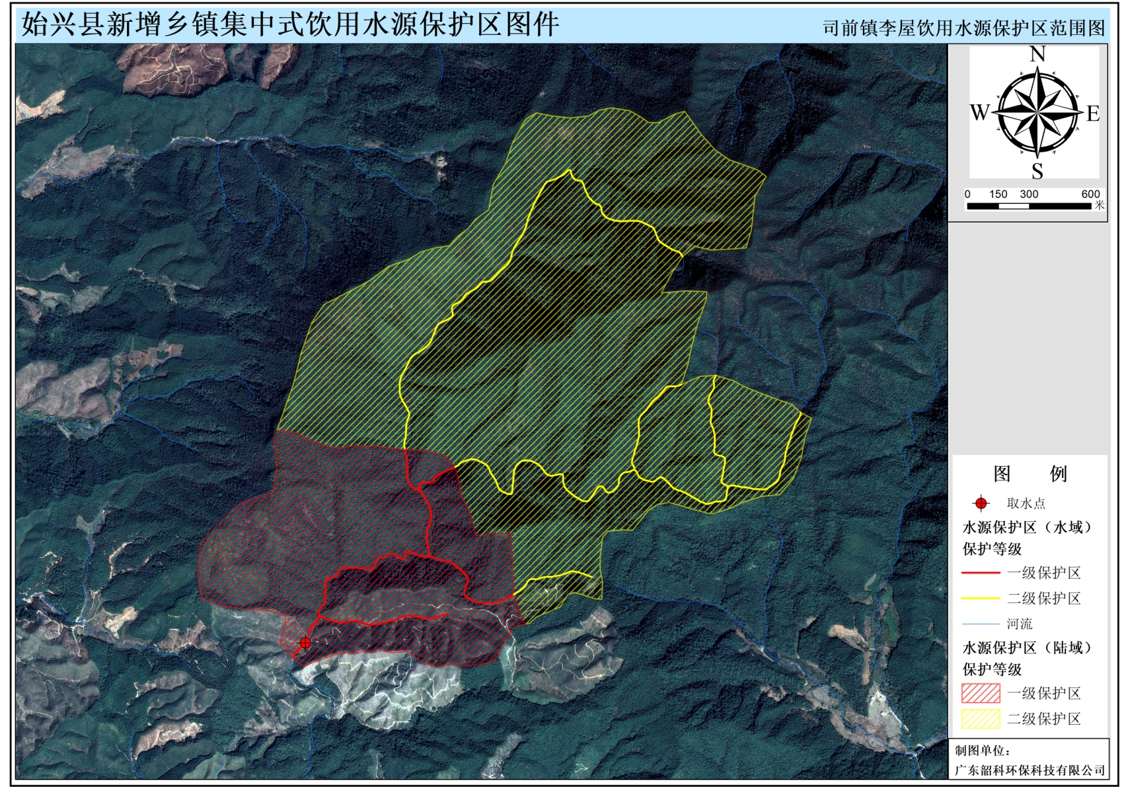

图4 隘子镇石井饮用水源保护区范围图

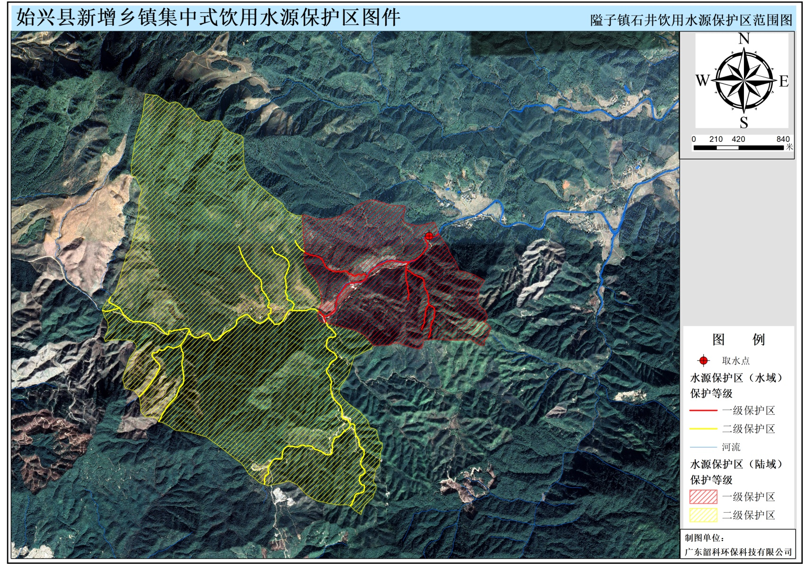

图5 深渡水瑶族乡太阳窝饮用水源保护区范围图

